HOW TO LINK GAIN ON FOREIGN EXCHANGE ACCOUNT in GST-03 item 12

- Setup in GST setting :
GST > GST Setting > Exempted Supplies
GST Realized Gain Account = forex gain account code
Tax Code = IES
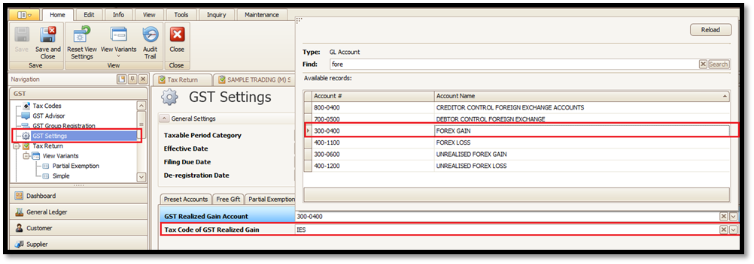
- Double check the IES Tax code setting in GST > Tax Codes :
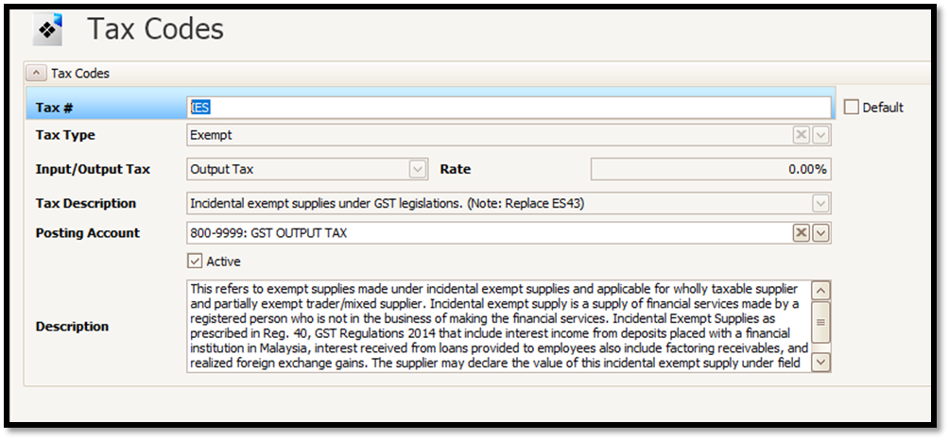

Example :
Create Invoice with USD rate 3.8
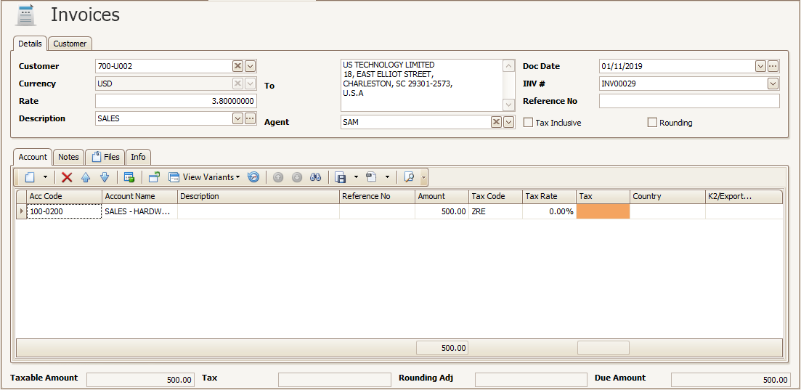
Make Payment USD rate 4.1
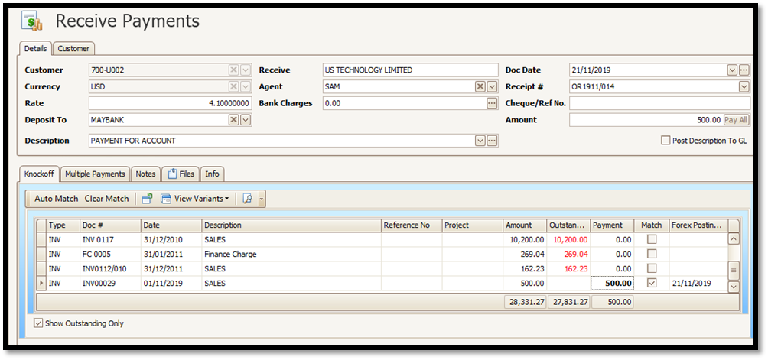
There will be foreign exchange gain RM150.

To link foreign exchange gain in GST-03 under item 12 :
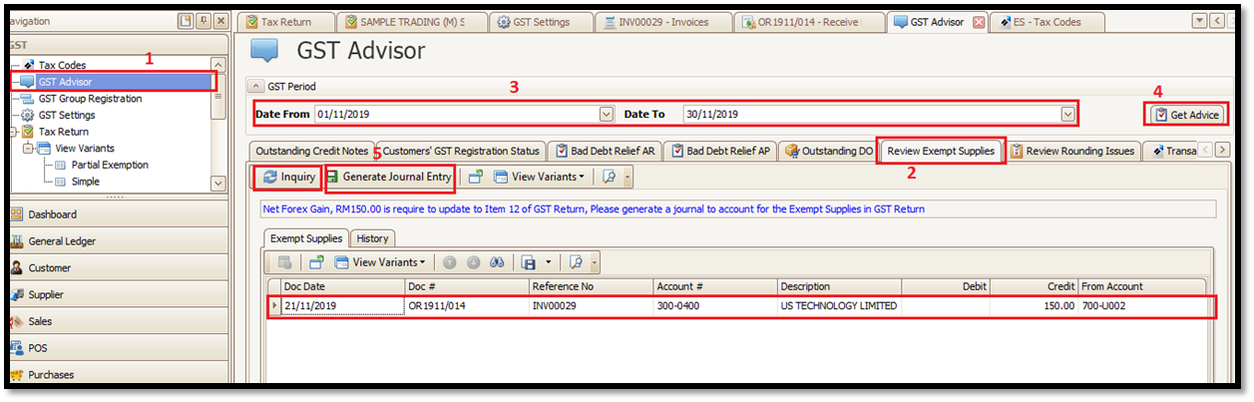
- Go to GST > GST Advisor > Review Exempt Supplies. Put the submission date & press Get Advice.
- If the Generate Journal Entry cannot click, press the inquiry button next to it.
- System will automatically create this exempt supplies transaction under Journal Entry.


