To Block User From Edit Unit Price (POS Module)
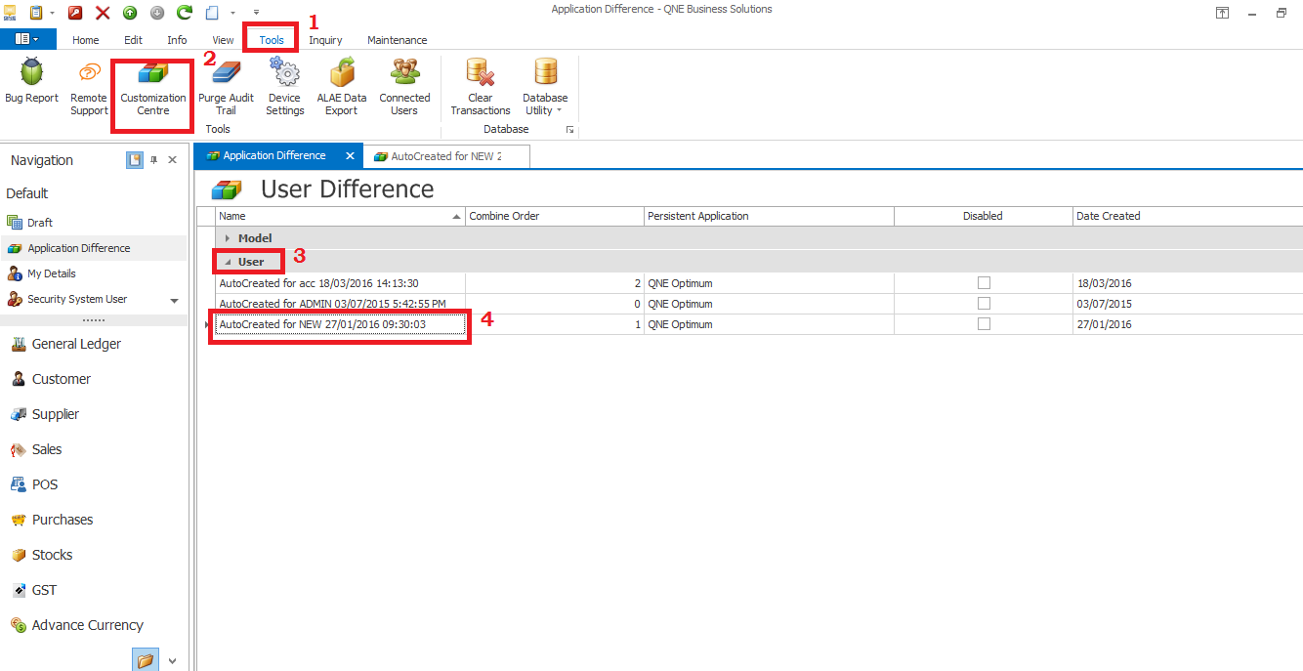
- Go to Tools>Customization Centre>User, double click on the user that want set blocking.

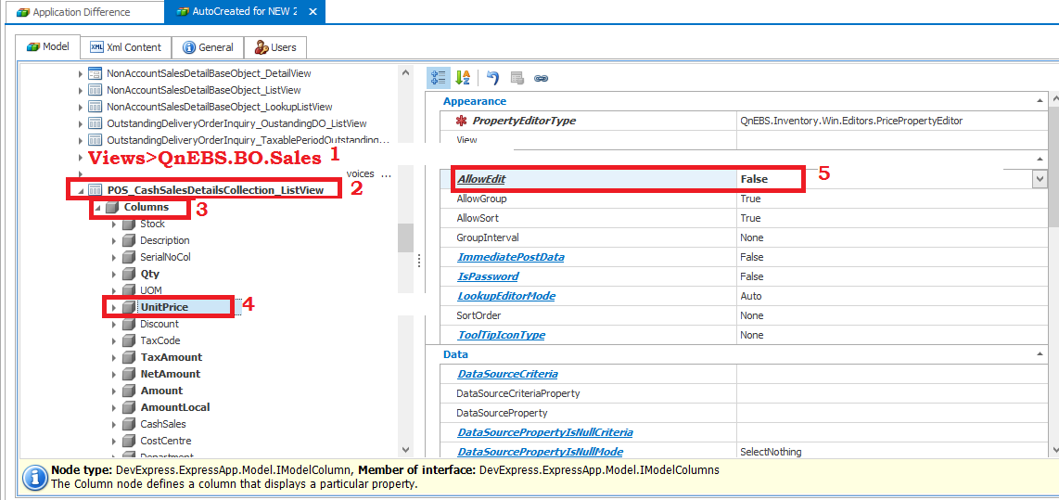
- Under Views>QnEBS.BO.Sales, you will find POS_CashSalesDetailsCollection_ListView, expand it.
- Expand Columns>click on UnitPrice>set AllowEdit to False.

