Services “SQL Server (QNEBSS)” doesn’t automatic start even already set start with Windows.
- Install Microsoft SQL Server Management Studio. If you haven't done this yet, please download the setup file from the links below and complete the installation before continue according to your PC’s Windows and bit.
Microsoft SQL Server Management Studio 2012(64 bit)
Microsoft SQL Server Management Studio 2012(32 bit)
Microsoft SQL Server Management Studio 2008(64 bit)
Microsoft SQL Server Management Studio 2008(32 bit)
Note: Microsoft SQL Server 2012 is not supported on windows XP. If you are using windows XP, please install Microsoft SQL Server Management Studio 2008.

- Connect to Server
Open Microsoft Management Studio, and connect to the server of your database.
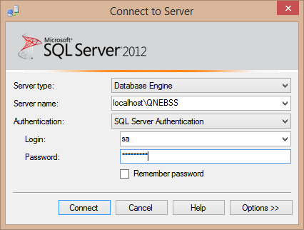
- Start a new Query by click on [New Query]

- Copy and Paste the following SQL Script into the New Query
ALTER DATABASE [msdb] SET ENABLE_BROKER;

- Execute the Query
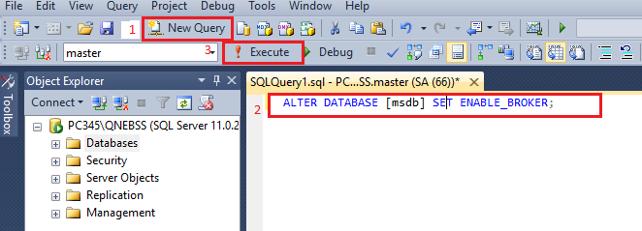

If after execute prompt messages:
Alter failed for database ‘msdb’
Cannot enable the Service Broker in database "xxx" because the Service Broker GUID in the database (guid number) does not match the one in sys.databases (different guid number)
ALTER DATABASE statement failed.
Execute below SQL script first:
ALTER DATABASE msdb SET NEW_BROKER WITH ROLLBACK IMMEDIATE

