Here’s how to apply Duo UOM in report format.
Let say for Item AAA :
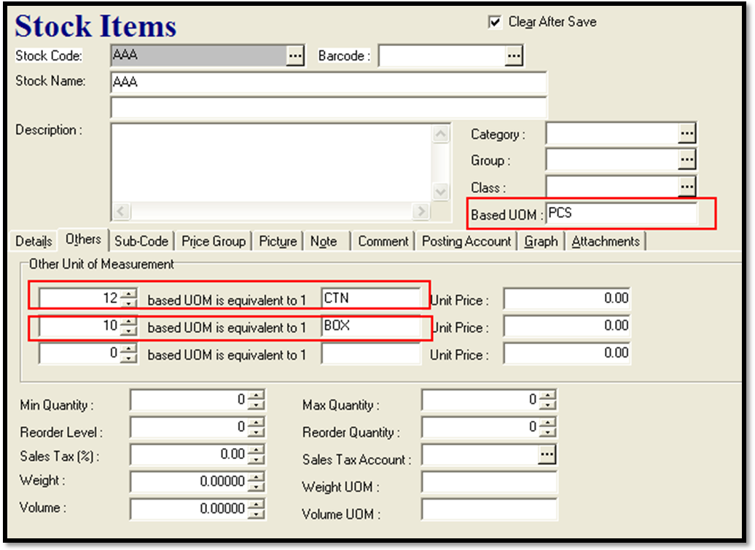
Based UOM = PCS
UOM1 = CTN (12 PCS =1CTN)
UOM2 = BOX (10 PCS =1BOX)

And the S.Invoice transaction =
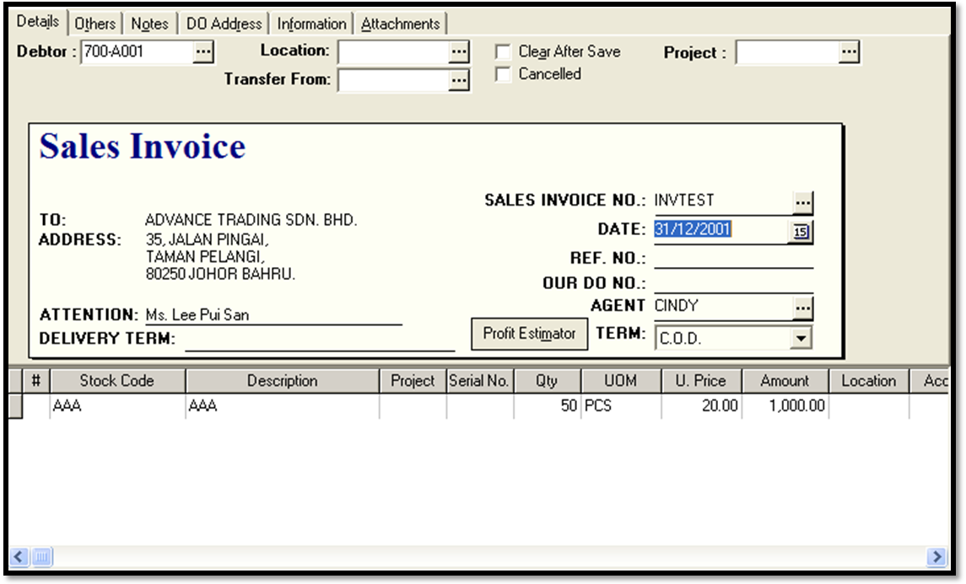
In the report result only 2 UOM can be displayed.
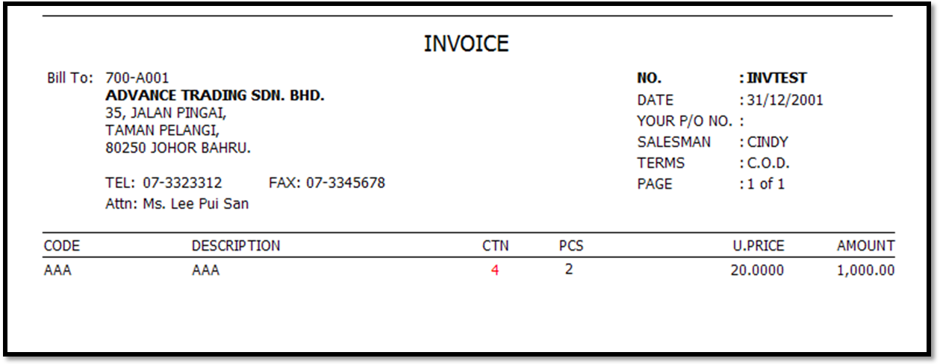
In report Builder,
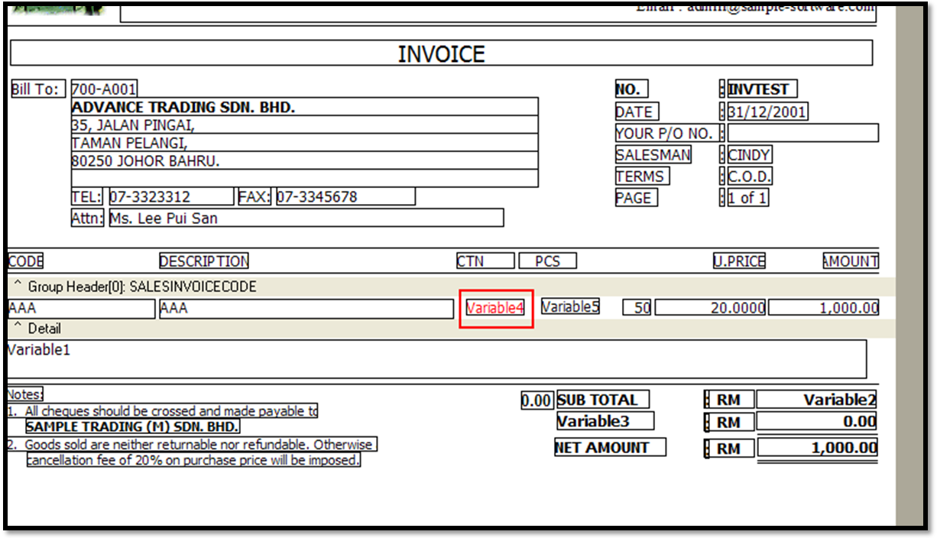

- Pull out Variable. Right click and select calculation.
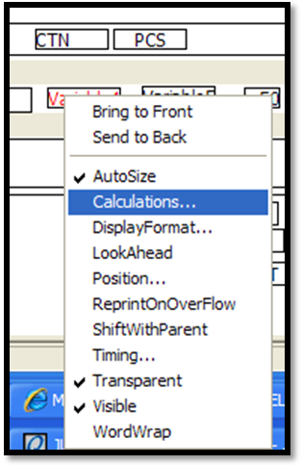
- If in CTN, the data = UOM1RATE.
But if in BOX, the data = UOM2RATE

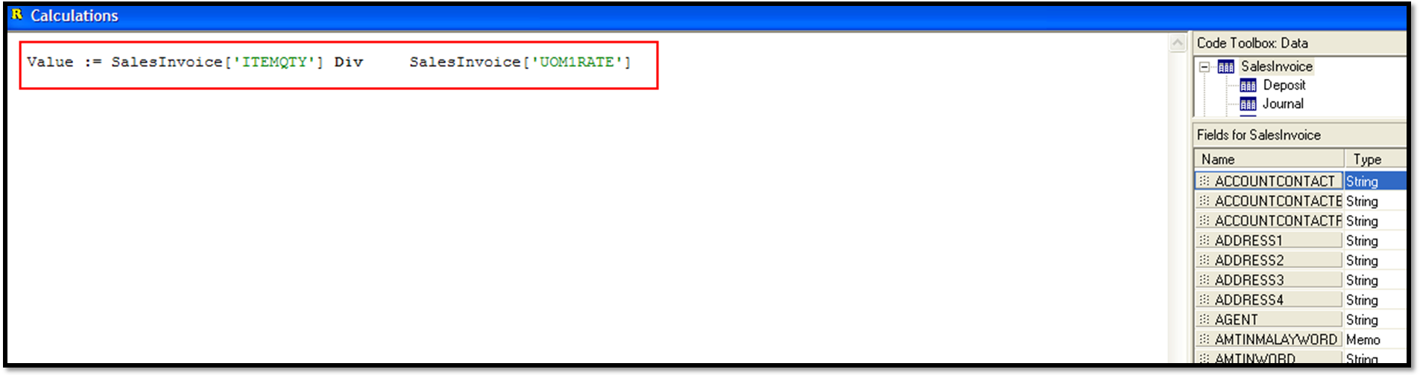
This is for CTN qty.
- For PCS qty :
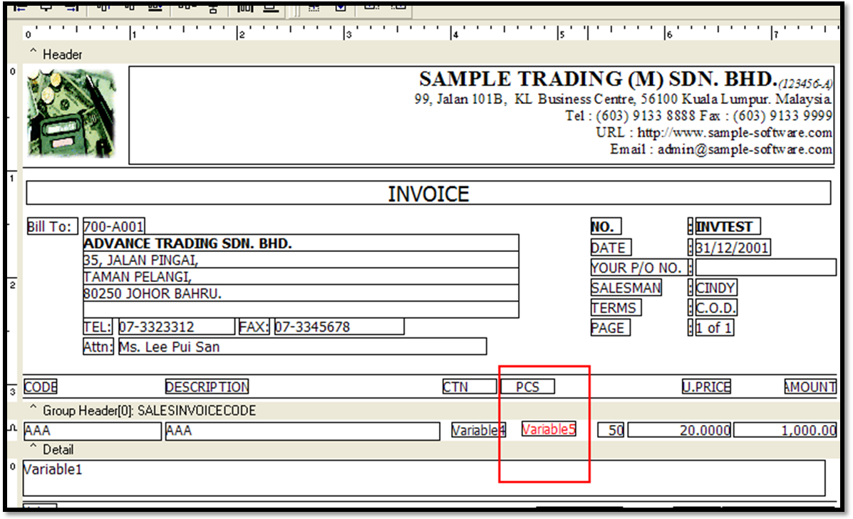
Pull out another variable, right click on it and select calculations



