Export User roles to different database

How to export user roles from one company to another company?

1. Database A

Create new role

Go to User Role 🡪 New

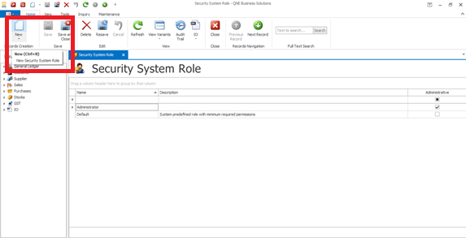

1. Grant Full Access for Sales and Marketing

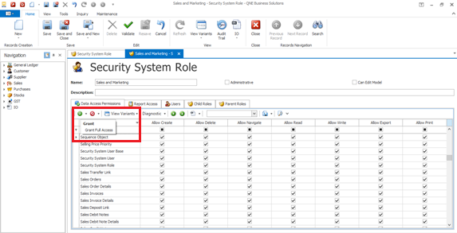

1. Next, IO🡪Serialization Configuration Group

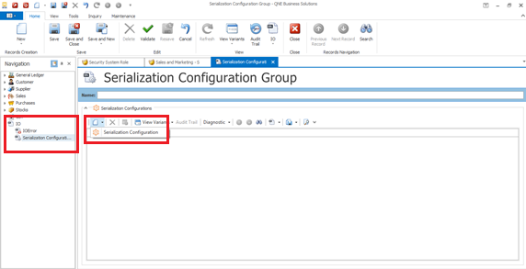

1. Type to serialize 🡪 Role

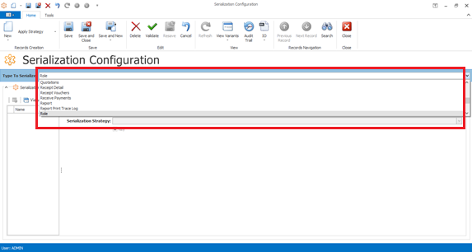

1. Apply strategy🡪Save and Close

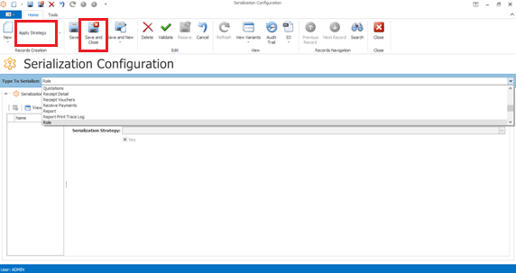

1. Right click on IO🡪Export🡪User Roles

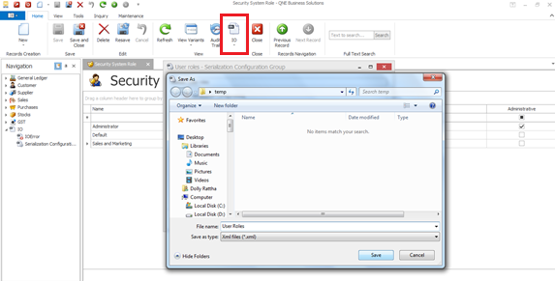

1. Database B

7.1 Import xml file from Database A, go to User roles

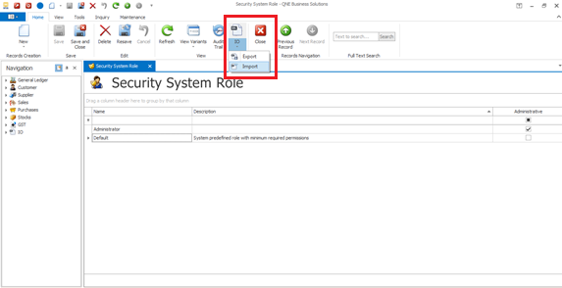

7.2 Choose the file

